PRACTICAL LAB: JAVASCRIPT OPERATORS MASTERY
Course: DFK20013 Web Design Technology
Topic: 3.1.1 Variables, Data Types, and Operators
Duration: 60 – 90 Minutes
Student Name | Tengku Muhamad Zafri Bin Tengku Shuhaidi
Registration No | 10DIT24F1215
Date | 4/3/2026

1. Learning Outcomes
By the end of this lab, students should be able to:
- Implement Arithmetic Operators for calculations.
- Use Assignment Operators to update values efficiently.
- Control application states using Increment/Decrement.
- Validate user access using Relational and Logical operators.

2. Practical Task: The All-in-One Operator Workshop
Create a file named lab_operators.html. Copy and complete the coding below.
HTML
<!DOCTYPE html>
<html lang="en">
<head>
<meta charset="UTF-8">
<title>DFK20013: JS Operators Workshop</title>
<style>
body { font-family: 'Segoe UI', sans-serif; max-width: 850px; margin: 2rem auto; background-color: #f0f2f5; padding: 20px; color: #333; }
section { background: white; padding: 25px; border-radius: 12px; margin-bottom: 25px; box-shadow: 0 4px 6px rgba(0,0,0,0.1); }
h2 { color: #2c3e50; border-left: 5px solid #3498db; padding-left: 10px; margin-top: 0; }
.output-box { background: #2c3e50; color: #27ae60; padding: 15px; border-radius: 6px; font-family: 'Courier New', monospace; margin-top: 10px; }
.short-note { background: #fff3cd; color: #856404; padding: 15px; border-radius: 6px; margin-top: 15px; border-left: 5px solid #ffc107; display: none; font-size: 0.9rem; }
input { padding: 8px; width: 100px; border-radius: 4px; border: 1px solid #ccc; }
button { padding: 8px 20px; background: #3498db; color: white; border: none; border-radius: 4px; cursor: pointer; font-weight: bold; }
button:hover { background: #2980b9; }
code { background: #eee; padding: 2px 4px; border-radius: 3px; font-weight: bold; color: #d63384; }
</style>
</head>
<body>

<header style="text-align: center; margin-bottom: 30px;">
<h1>JavaScript Operators Mastery</h1>
<p>Follow the steps and observe the Console and UI outputs.</p>
</header>

<section>
<h2>Task 1: Basic Arithmetic (Check Console)</h2>
<p>This task demonstrates background calculations using <code>+</code>, <code>-</code>, <code>*</code>, <code>/</code>, <code>**</code>, and <code>%</code>.</p>
<button onclick="runTask1()">Run Console Logic</button>
</section>

<section>
<h2>Task 2: POS System (Arithmetic & Assignment)</h2>
<p>Price: RM 50.00. <strong>Promo:</strong> Buy > 4 units to get RM 20.00 discount.</p>
Quantity: <input type="number" id="qty" value="1">
<button onclick="runTask2()">Calculate Total</button>
<div id="outPOS" class="output-box">Final Total: RM 0.00</div>
<div id="notePOS" class="short-note"></div>
</section>

<section>
<h2>Task 3: Stock Control (Increment & Decrement)</h2>
<p>Simulating inventory updates.</p>
Stock Level: <span id="stockVal" style="font-size: 1.5rem; font-weight: bold;">10</span><br><br>
<button onclick="runTask3('inc')">Add (+)</button>
<button onclick="runTask3('dec')" style="background:#6c757d;">Remove (-)</button>
<div id="noteStock" class="short-note"></div>
</section>

<section>
<h2>Task 4: Gate Access (Relational & Logical)</h2>
<p>Rules: Age 18+ OR (Age 13+ AND Parent present).</p>
Age: <input type="number" id="age" placeholder="Age">
<label><input type="checkbox" id="parent"> With Parent?</label><br><br>
<button onclick="runTask4()" style="background:#27ae60;">Verify Entry</button>
<div id="outSecurity" class="output-box">Status: Waiting...</div>
<div id="noteSecurity" class="short-note"></div>
</section>

Inside the <script> tag, type all the following code:
JAVASCRIPT:
1. | 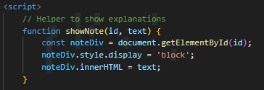
2. | 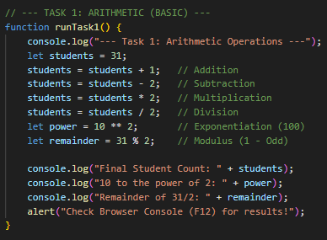
3. | 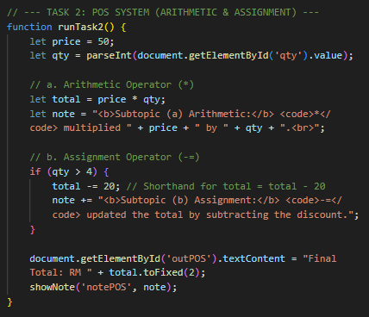
4. | 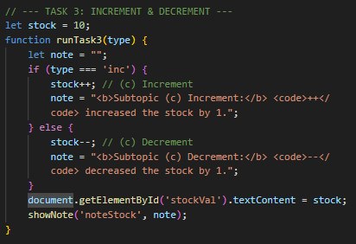
5. | 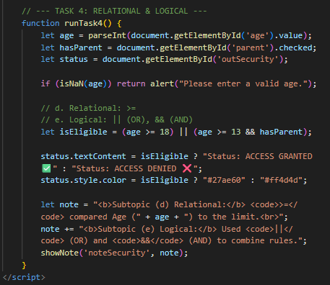

Capture a screenshot of the output from the previous steps. Observe the results and explain your understanding of the process.
1. | Screenshot of the output  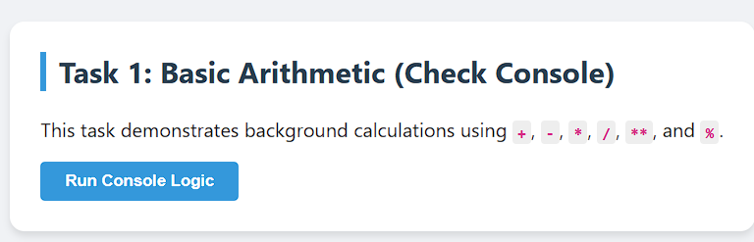  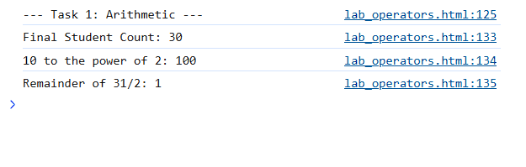
Explanation
This task proves how arithmetic operators manipulate values and how modulus can check even/odd numbers.

2. | Screenshot of the output  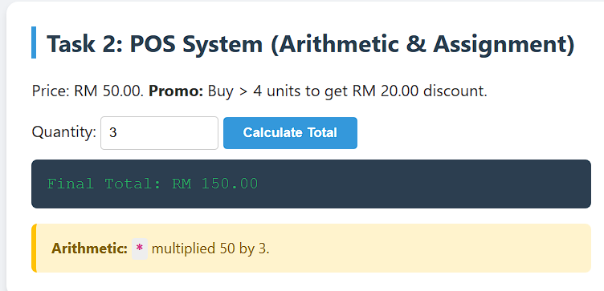
Explanation
Demonstrates how arithmetic (*) calculates totals and how assignment (-=) efficiently updates values without rewriting the full equation.

3. | Screenshot of the output  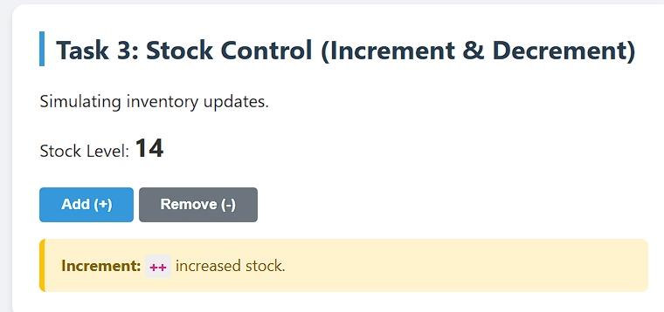
Explanation
Shows how ++ and -- are shortcuts for adding or subtracting 1, useful in counters or inventory systems.

4. | Screenshot of the output  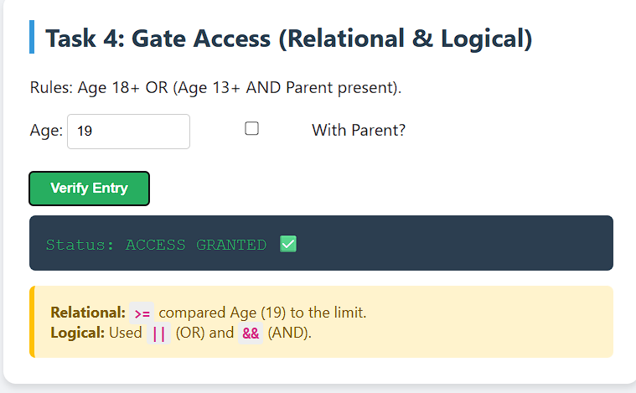
Explanation
Demonstrates how relational operators compare values and logical operators combine conditions to enforce rules.

5. | Screenshot of the output  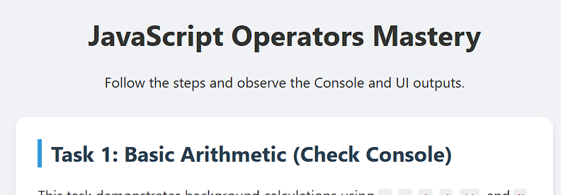
Explanation
This section is for inserting screenshots of your outputs and writing observations. It ties the coding results back to the learning outcomes, proving that operators work as expected in real scenarios.

3. Quick Check (Reflection)
Instruction: Answer the following questions based on your coding results.
- Modulus Utility: Based on Task 1, if students % 2 returns 0, is the number even or odd?
- If students % 2 returns 0, the number is even.
- Explanation: Modulus gives the remainder after division. Even numbers divided by 2 always leave remainder 0, while odd numbers leave remainder 1.
- Shorthand Power: In Task 2, rewrite total -= 20 using the standard assignment method
- total -= 20 rewritten in standard assignment form is: total = total - 20;
- Explanation: The shorthand -= is just a compact way of writing subtraction assignment
- Logical Priority: In Task 4, why did we put (age >= 13 && hasParent) in parentheses?
- We put (age >= 13 && hasParent) in parentheses to ensure it is evaluated together before applying the OR (||) condition.

- Explanation: Without parentheses, operator precedence might cause confusion. Grouping makes the logic clear: “Age ≥ 13 AND parent present” must be treated as one rule before comparing with “Age ≥ 18”.

- Time Calculation: (Extra Challenge) If a variable totalMinutes = 130, write the formula to find the remaining minutes after converting to hours using the Modulus operator.
- If totalMinutes = 130, the formula to find remaining minutes after converting to hours is: let remainingMinutes = totalMinutes % 60;
- Explanation: Dividing by 60 gives hours, modulus by 60 gives leftover minutes. For 130 minutes, 130 % 60 = 10, so the remainder is 10 minutes.

